Parts of a Trilobite Lesson Plan (Grades 6-12)

Tennessee State Standards Covered
GLE 0607 and 0707. Inq. 4 Develop questions for future exploration of trilobites
GLE 0607 and 0707. Inq. 5 Communication scientific understand via descriptions and models
GLE 0807.5.1 Identify parts of a trilobite that make it unique
GLE 0807.5.2 Use a classification key for trilobites
CLE 3210.5.1 Associate parts of trilobite with lifestyle
CLE 3255.1.1 Implement strategies used to identify a trilobite
CLE 3205.4.5 Relate environmental change to trilobite extinction
CLE 3205.4.7 Emphasize trilobites as evidence of past life

The Parts of a Trilobite Lesson Plan is used to introduce the vocabulary associated with the external parts of a trilobite. Generally, it is important to begin the lesson with a discussion of the parts while looking at an actual specimen. Because fossils are sometimes incomplete or missing parts, you will need to be sensitive to your students’ ability to compare the real fossil with a picture representation of the animal. Use only complete fossils with younger students who can’t yet conceptualize parts that might be missing. With the fossil “parts of…” lessons, students are looking at drawings of familiar fossil animals.

Trilobite Lesson Plan Goals:
- To learn the external parts of the trilobite.
- To understand how the trilobite used its parts.
- To increase vocabulary.
- To develop a background of information that will be used in classification.
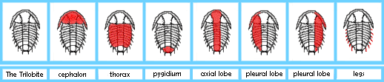
- For younger students, introducing new vocabulary as sight words along with a reading and writing component to support memorization.

Trilobite Lesson Plan Materials
Trilobite fossil
- Picture of a complete trilobite
- “Parts of a Trilobite” materials
  - How to make parts of fossils materials Pictures with parts emphasized in red.
  - Download the PDF file here for a free printable version of The Trilobite pictures for making materials
  - Definitions with Labels
  - Definition without labels
  - Separate labels for matching to the definitions
  - External Parts of a Crinoid control (answers) booklet,
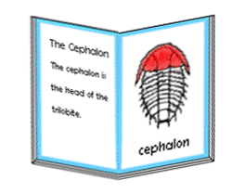
Trilobite Lesson Plan Presentation
- Introduce the trilobite with a real fossil, pointing out the parts in a group discussion. If a fossil is not available to you, a large picture or drawing will work, but nothing makes an impression like the real thing. As you point out the parts of the trilobite, talk about what each part does to help the animal survive. See www.fossils-facts-and-finds.com for information on the body functions of the trilobite.
- This would be a separate lesson with younger students; it could be a continuation with older students, especially if they are familiar with this type of material.
  - Lay out the pictures in a horizontal line. Lay out the definitions with labels in a vertical line on the left side of your presentation space. As you do this, students may spontaneously read the labels out loud. Point out the red part. Say the name. Find the card with the matching definition and label. Read the definition; then lay it under the picture. Continue with this left to right. Use the control booklet to check the answers.
  - Follow up activities for the Trilobite Lesson Plan
    - Use the definitions without labels in a similar manner for a greater level of challenge for the students.
    - Make a trilobite booklet.
    - Make a trilobite wall chart.

